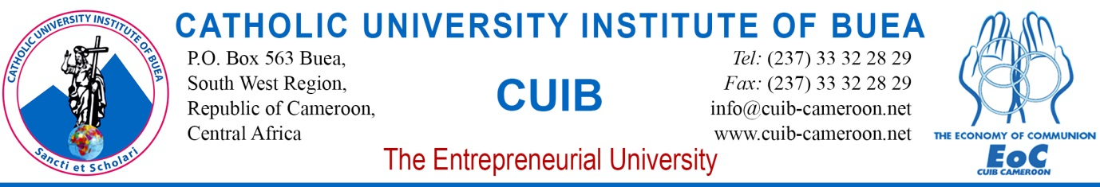

COLLOQUIUM / GUEST SPEAKER EVENT
Wednesday, January 17, 2018
EoC Village, Molyko Campus at 12:45 pm prompt

Presentation By: Roland Kwemain, Founder and CEO, GO Ahead Africa Ltd
Theme: “Effective time Management as a Key Success factor in leadership and Entrepreneurship”

SN | Time | Duration | Activity | Person Responsible
1 | 12:45pm 12:55pm | 10 min | Brief Audience with the President /Pro Chancellor of the University | Office of the President, Campus Security
2 | 12:55pm-12:59Pm | 04 min | Procession to The EoC Village | Campus Security
3 | 12:59pm – 1:00pm | 1min | Opening Prayer | Rev. Fr. Njoh Moses, Campus Ministry
4 | 1:00pm – 1:05pm | 5min | Welcome Remarks | Rev.Fr. George Nkeze Jingwa (Ed.D), President CUIB
5 | 1:05pm – 1:10pm | 5min | Presentation of the Speaker | Communication Services
6 | 1:10pm- 1:40pm | 30min | Keynote Address | Guest Speaker
7 | 1:40pm – 2:00pm | 20min | Question and Answer Session (Faculty, Staff and Students of CUIB) | Response by Guest Speaker
8 | 2:00pm – 2:05pm | 5min | Presentation of Gift | Mr Eyong Eyong Thaddeus, VP i/c EI
9 | 2:05pm - 2:10pm | 5min | Vote of Thanks | Rev.Fr. George Nkeze Jingwa (Ed.D), President CUIB
10 | 2:10pm – 2:12pm | 2min | Closing Prayer | Rev. Fr. Njoh Moses, Campus Ministry
11 | 2:12pm – 2:20pm | 8min | Photos | Communication Services
12 | 2:20pm – 2:30pm | 10min | Brief Interview of the guest | Communication Service
13 | 2:30pm | 30min | Lunch | St Martha’s Restaurant

COLLOQUIUM / GUEST SPEAKER EVENT
Wednesday, January 17, 2018
Profile of the Speaker

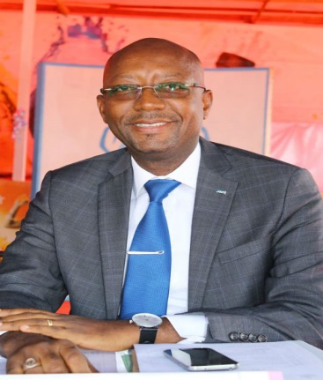

Name: Roland Kwemain
Date of Birth: 1971.
Place of Birth: Yaounde, Cameroon.
Nationality: Cameroonian
Marital Status: Married
Telephone: (+237) 699-924-730,
(+237) 679-172-309
(Whatsapp)

- Mr Roland Kwemain holds a Master’s degree in International Management from IAE de Poitiers, France. He earned a diploma on “CSR and Sustainable Development” from the world Bank Institute.
- Kwemain is the Executive Director of ADCOME focuses on empowering youth and communities with 21st Century ICT skills. So far, ADCOME has installed more than 80 multi media centres in Cameroon, reaching about 300.000 students.
- He is the Chairman of Go Ahead Africa Ltd, a leadership and management training and consultancy firm. As part of her CSR policy, Go Ahead Africa Ltd organizes the Cameroon Leadership Academy. It is a free annual leadership program focused on training, empowering and providing network opportunities for 100 young Leaders and Entrepreneurs. He is a coach and motivational speaker on Leadership and Entrepreneurship.
- He is a member of the Board of Trustees of the Catholic University Institute of Buea. He is the President of the Catholic Men Association of Cameroon.
- As JCI president, Mr Roland Kwemain has travelled extensively to more than 70 countries worldwide where JCI is established. During his visits, he met with thousands of young active citizens, Heads of state, community leaders and corporate leaders.

He resides in Buea with his wife and three children. He speaks French and English.

